On the Fourier series truncation peaks at subatomic resolution

Anne Bochow and Alexandre Urzhumtsev

Physics Department, Faculty of Sciences and Technologies,
University H. Poincaré Nancy 1,
B.P. 239, 54506 Vandoeuvre-lès-Nancy, France

- Introduction

Recently, several macromolecular structures have been resolved at a subatomic resolution as can be found in PDB (Berman et al., 2000; Berstein et al., 1977). At such a resolution, new structural details become visible at the corresponding Fourier maps. A small size of these details requires more careful analysis of the images of the electron density. In particular it is important to avoid confusion between signal and noise.
The noise in Fourier maps can be attributed to several factors: errors in the experimental magnitudes, phase errors, Fourier series truncation. Some analysis of the first two sources of errors on macromolecular images at subatomic resolution has been reported previously (Afonine et al., 2004). This article addresses the role of errors in images caused by the resolution cut-off when this latter is unusually high for macromolecules, above 1 Å.
The problem of Fourier series truncation is well known in macromolecular crystallography. At a very low resolution the ripples have a large scale and may systematically increase or decrease the values of the Fourier map in large regions. They complicate the definition of the correct molecular envelope. However, there are too few structural studies at such a resolution to bring much attention to this difficulty. At a conventional resolution of 2-3 Å, in general these errors do not pose particular difficulties due to a relatively weak effect. In most of cases, they are mentioned in relation to analysis of isolated ions or solvent molecules.
It is known from many decades of studies on small molecules that at a subatomic resolution the noise caused by the series truncation is very significant. One of the main reasons for such increasing noise are very low values of the atomic displacement factor B which may reach 1-2 Å² for such extremely well ordered structures. To decrease the noise in density deformation studies, this density is analysed at difference maps.
The goal of the study presented here is to numerically compare the size of the density peaks due to density deformation with those caused by the series truncation. Not only the size of the noise peaks but also their shape is important to make a distinction between the noise and the signal. Both conventional and difference maps are studied.

- Test data

The tests were conducted with the data previously described by Afonine et al. (2004). For a peptide model, placed in an orthogonal unit cell with parameters a=b=18 Å, c = 15 Å, two sets of structure factors have been calculated. First, the density was calculated without taking atomic interactions into consideration. For each atom, its electron density distribution ρ^{spher}(r;B) was generated as a spherical function with conventional 5-gaussians atomic factor (Brown et al., 1999). Initially all atoms were considered as immobile with B = 0 Å². From this electron density, a set of Fourier coefficients {F^{spher}(s)exp[iϕ^{spher}(s)]} was calculated at the resolution of 0.3 Å (the highest resolution at which a X-ray structure was determined is 0.25 Å, Takahashi et al., 1998). Secondly, an electron density distribution ρ^{cryst}(r;B) was calculated by the quantum-chemical DFT method (program SIESTA, Sanchez-Portal et al., 1997) taking into account atomic interactions. Another set of Fourier coefficients {F^{cryst}(s)exp[iϕ^{cryst}(s)]} obtained from this new density corresponded to structure factors of a crystal. Their magnitudes simulated the structure factor magnitudes obtained from the diffraction experiment. Comparative tests, conducted with these simulated data and with experimental data available for several other molecular crystals have shown that this method reproduces very realistically the practical situation (Afonine et al., 2004).
The difference between these two density distributions
ρ^{diff}(r;B) = ρ^{cryst}(r;B) - ρ^{spher}(r;B)
allowed for the estimation of the height of the density deformation peak at peptide bonds as roughly 0.4-0.5 e/Å³. These peaks are reproduced quite exactly in the maps of the resolution of d = 0.5 Å and higher. In the maps at a resolution of about d = 0.9 Å, the peak value decreases roughly to 0.3-0.4 e/Å³. With B increasing, the value of the peaks decreases. For this study, the centre of attention was the analysis of the deformation density and the noise around the C-C bond where the deformation density peak is roughly in the middle of the bond.
To analyse the perturbations influenced by the Fourier series truncation a series of maps with the Fourier coefficients {F^{spher}(s)exp[iϕ^{spher}(s)]} at various resolution d was calculated. Since these maps show the image of the electron density corresponding to the model of spherical atoms, all peaks except those at the atomic centres are noise.

- Main features of the noise

Fig. 1 shows a typical image of electron density, calculated from a spherical-atoms model at the resolution of 0.5 Å. One may note the blob at the C-C bond, the disk at the C-N bond and the ring at the C=O bond.
This shape of the noise can be understood given the image of an isolated atom as a central spherical peak surrounded by a series of ripples. For two more or less identical neighbouring atoms the superposition of such distributions gives an image with a cylindrical symmetry around the interatomic vector. The superposed ripples from the two atoms may form rings or blobs, depending on the distance to atomic centres and on the resolution. It is easy to estimate from one-dimensional analysis of images of the δ-function at the resolution d that the closest noise peak is at the distance roughly 5d/4 to the centre of the main peak. This allows a fast estimation for 2 bonded atoms to be done. The first noise peaks are superposed in the middle of the bond (that is the position of the deformation density peak for C-C) at the resolution 0.5-0.6 Å. At lower resolutions, the superposition should happen outside of the bond. In this case, the noise peak forms a ring with radius decreasing with the resolution.
A more precise analysis was conducted for the series of maps calculated with the coefficients {F^{spher}(s)exp[iϕ^{spher}(s)]} at the resolution d. For each map the mean density values <ρ(R;d)> were calculated at the distance R to the centre of the C-C bond in the plane perpendicular to this bond at its middle. The maps were calculated for different B values. Corresponding curves are shown in Fig. 2.
At the resolution d = 0.9 Å (with the atomic factor B = 0) the first peak is at the distance R ≈ 0.9-1.0 Å from the bond (there is a noise ring of this radius), and its value is larger than the value of the deformation density peak. However, at such a resolution the noise in the middle of the bond is negligible. At a resolution of about d = 0.7 Å, the noise ring is closer to the bond, and the peak is higher. The noise in the middle again is negligible. When the resolution approaches d = 0.5 Å, the ring “collapses” at the bond between the two atoms. The value of the corresponding peak is one order of magnitude larger than the deformation density. When the resolution increases further, there is no more ripple superposition in the middle of the bond and this noise peak decreases.
The characteristics of the image are similar when B is different from 0. The curve smoothens, the ripples become less and less pronounced and the density in the middle of the bond becomes larger. However, it is much less for d = 0.7 Å than for d = 0.5 Å, as previously for B = 0. At the same time, the deformation density peaks decreases (Afonine et al., 2004) but is still significant at least for B < 5 Å².

- Density images

Fig. 3 shows a series of three-dimensional images of the Fourier maps calculated at different resolution from 0.9 Å to 0.3 Å. In all cases the displacement factor B is equal to 0. As expected, the maps confirm the analysis of the curves shown in Fig. 2. Several complementary details can be observed. Since the height of the peaks and the noise increase significantly with the resolution, we failed to present well-illustrative images at the same cut-off density level.
At the resolution of 0.9 Å each of rings (rather, their arcs) belongs to several neighbouring bonds at the same time. At 0.7 Å these merged arcs are separated into individual full rings, one per bond. At 0.6 Å the radius of these rings is significantly smaller and the density is larger. At 0.5 Å the rings for all bonds but C=O collapse into a blob. These blobs should not be confused with the deformation density. The noise around the C=O bond behaves slightly differently due to a particular asymmetric character of this bond. This is also reflected in a particular behaviour of the corresponding deformation density. At resolution 0.4 Å these blobs are decomposed into separated small rings, which are shifted from the middle of the bond towards the atoms. Noteworthy, the ring shown for the C=O is a new ring, corresponding to the superposition of second ripples, while the first ring is attached to the central peak of the O atom (Fig. 4a). This phenomenon continues at 0.3 Å. At the resolution of 0.3-0.4 Å ripples can be seen inside the central “atomic” peak.
When similar images are analysed for larger values of B, both rings and blobs start to merge with the major peaks but continue to be seen until B reaches a critical limit (see a discussion in Afonine et al., 2004). Fig. 4b shows a superposition of two 0.5 Å-resolution maps calculated at B = 0 and at B = 2 Å². In the second map, the blob at the C-C bond is seen equally well as in the first map while of coarse at a lower cut-off level.

- Images of difference density

The results given above show the importance of the computational noise when working at subatomic resolution. To avoid ripples in high-resolution images, crystallographers that work with small-molecule crystals use difference maps. There are two main ideas behind this approach. First, in conventional maps it is easy to see heavy (non hydrogen) atoms and many hydrogens; when looking for details at the next level, it is advisable to remove the main contribution already known. Second, it is known that there are ripples caused by heavy atoms showing large and sharp density peaks. Removing these peaks will stop ripples.
As illustrated by Afonine et al. (2004) the model refinement at a subatomic resolution often leads to the models where the values of the atomic factor B are larger than the real values. In this case, there is a risk of residual peaks and, as a consequence, a risk of residual ripples. To simulate such a situation the difference density has been calculated at the resolution of 0.5 Å with the coefficients
{F^{spher}(s)exp[iϕ^{spher}(s)]}_{B=1} - {F^{spher}(s)exp[iϕ^{spher}(s)]}_{B=2}

This image corresponds to the situation when the true value of B for all atoms is equal to 1 Å² but during refinement it has been estimated as 2 Å², similar to values found by Afonine et al., 2004).
Fig. 4c shows the corresponding Fourier map. The image is similar to the conventional map at 0.5 Å resolution, though the corresponding distribution is much lower. There is a significant peak in the middle of the C-C bond due to the Fourier series truncation. Its height is about 0.5 e/Å³, the same as the height of the peak for the deformation density. At such a “resonance” resolution, when the superposition of the noise ripples creates a peak directly on the bond, there is still a high risk of confusion between the deformation density and the computational noise. Fig. 4c confirms that this problem may not be resolved even with difference maps traditionally used for studies of deformation density
As shown previously, it is very important to include all available data into refinement, that helps to estimate B values as precise as possible (Afonine et al., 2004). With correct B values, the deformation density peaks can also be seen in lower resolution maps. Our study suggests that even with the availability of 0.5 Å high-resolution data, it is worthy to calculate density maps at lower resolution. This is important to verify if the peaks indicate deformation density or computational noise. The computational noise would not be conserved but deformed or it would disappear.

- Conclusions

In this study the behaviour of noise in Fourier maps at subatomic resolutions is shown. The shape of noise peaks is very specific. In most cases the bonds are surrounded by noise rings with a radius decreasing with the resolution.
A critical resolution is at about 0.5 Å when the rings transform into blobs at the interactomic bonds. These noise peaks could easily be confused with deformation density.
At this critical resolution the noise blobs may be present even at difference maps, traditionally used for deformation density studies. The value of the noise is comparable to the size of peaks of deformation density. This may be a source of an important confusion.
As a practical tool, this study suggests that when working at subatomic resolution, it is worthwhile to analyse a series of maps at a resolution below the limit. With this procedure the consistence of the peak which is supposed to indicate a deformation density can be verified. Especially strong inconsistencies may be observed when switching from 0.5 Å resolution maps to 0.7 Å resolution maps. In this case, the peaks can most likely be contributed to the Fourier series truncation effects and therefore do not indicate deformation density.

The authors thank V.Yu.Lunin for his suggestion to analyse the characteristics of noise peaks and P.Afonine for providing the data. This study has been conducted as part of a project towards a Master in Physics by A. D. Bochow.

References

Afonine, P.A., Lunin, V.Yu., Muzet, N., & Urzhumtsev, A. (2004). Acta Cryst., D60, 260-274
Berman, H.M., Westbrook, J., Feng, Z., Gilliland, G., Bhat, T.N., Weissig, H., Shindyalov, I.N. & Bourne, P.E. (2000). Nucleic Acids Research. 28, 235-242.
Bernstein, F.C., Koetzle, T.F., Williams, G.J., Meyer, E.F. Jr., Brice, M.D., Rodgers, J.R., Kennard, O., Shimanouchi, T. & Tasumi, M. (1977). J.Mol.Biol. 112, 535-542.
Brown, P.J., Fox, A.G., Maslen, E.N., O’Keefe, M.A. & Willis, B.T.M. (1999). International Tables for Crystallography, Vol. C., Wilson, A.J.C. & Prince, E., eds., Kluwer Academic Publishers, Dordrecht, Boston, London, 548-589.
Sanchez-Portal, D., Ordejon, P., Artacho, E. & Soler, J.M. (1997). Int. J. Quant. Chem., 65, 453-461.
Takahashi, Y., Ohshima, K.-i., Yamamoto, K., Yukino, K. & Okamura, F.P. (1998) J.Appl. Cryst., 31, 917-921

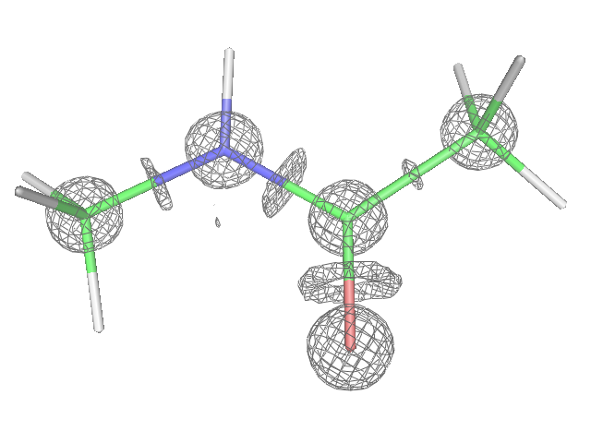
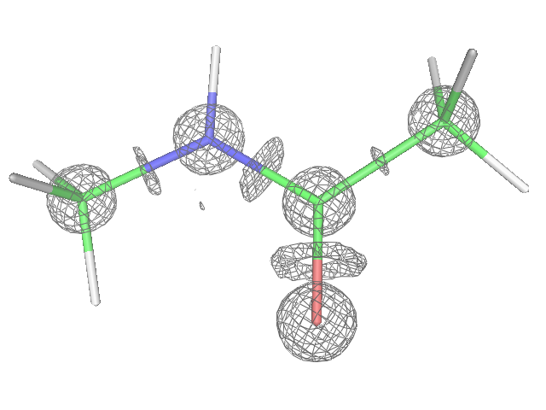

Fig. 1. Map calculated with the Fourier coefficients {F^{spher}(s)exp[iϕ^{spher}(s)]} at the resolution of 0.5 Å for B = 0 ; cut-off 3.5 e/Å³ .

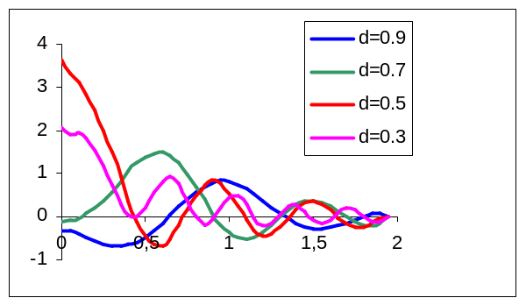
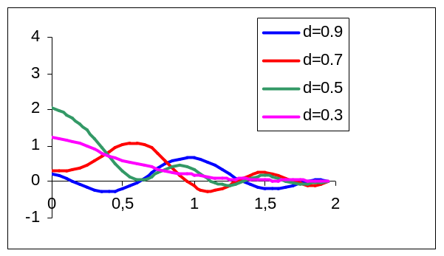
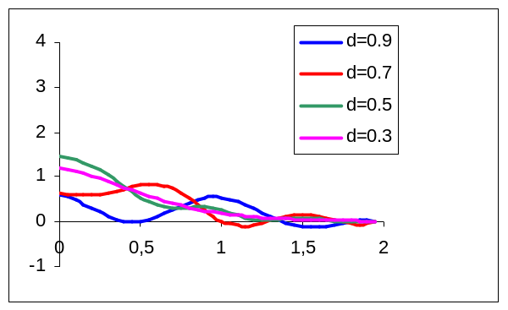
B=0
B=1
B=2

Fig. 2. Mean density in the plane perpendicular to the C-C peptide bond, taken at the middle of the bond, as a function of distance to the bond

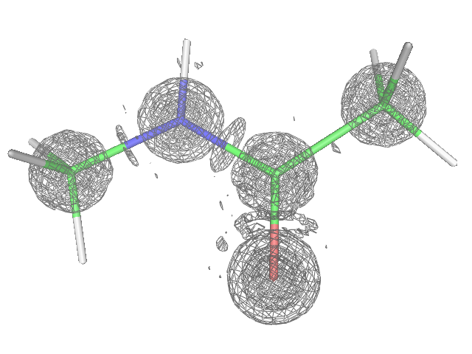
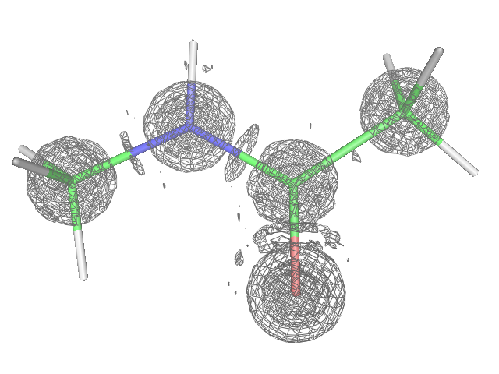
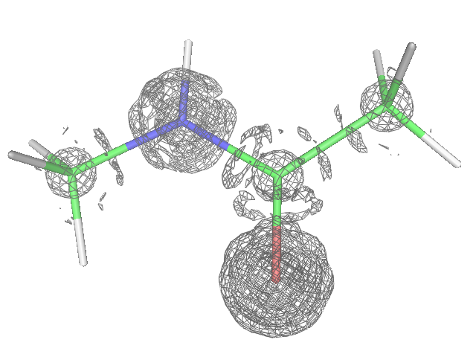
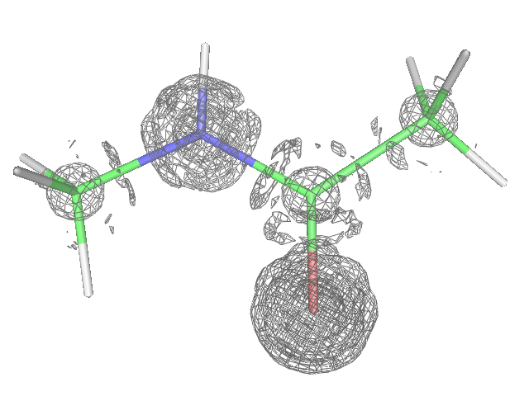
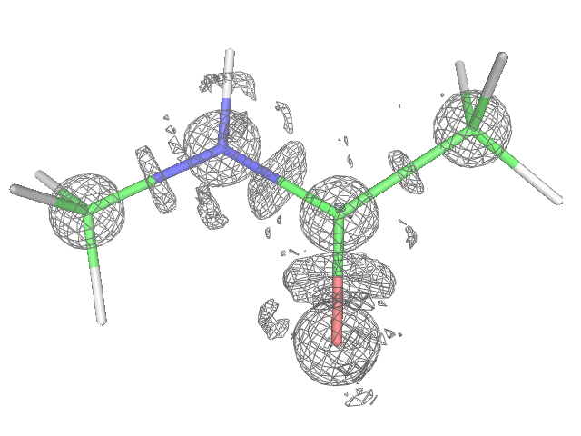
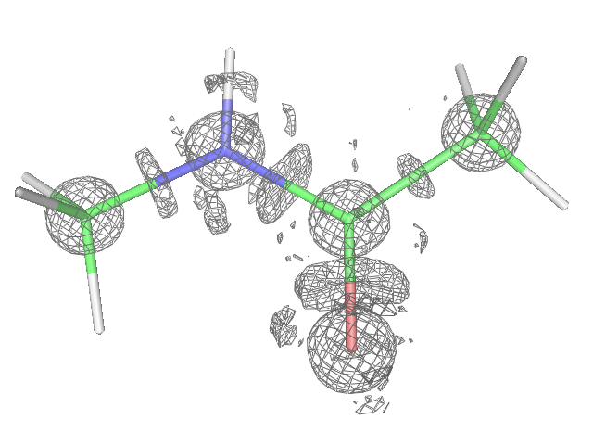
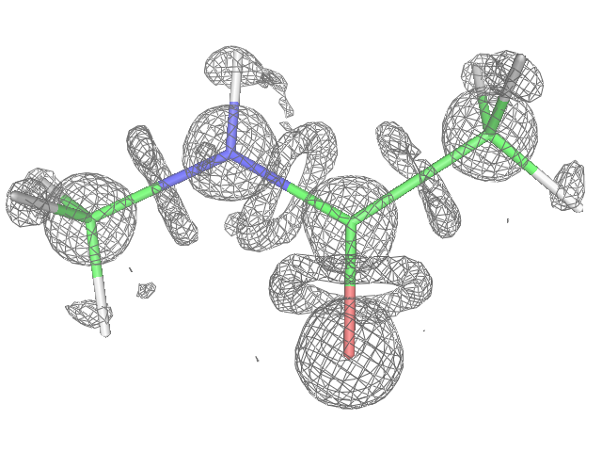
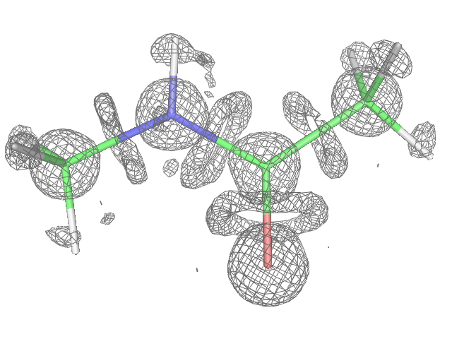
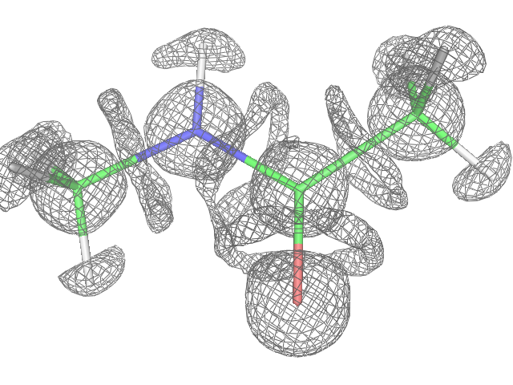
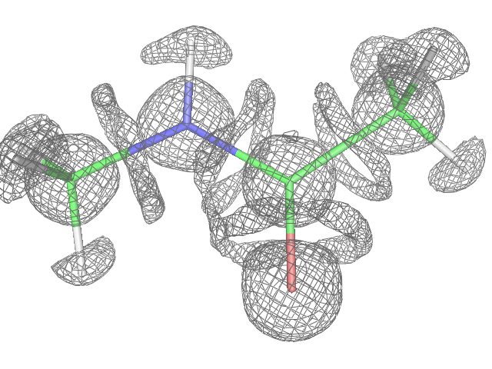
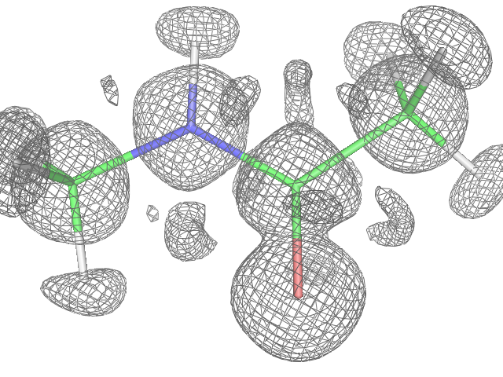
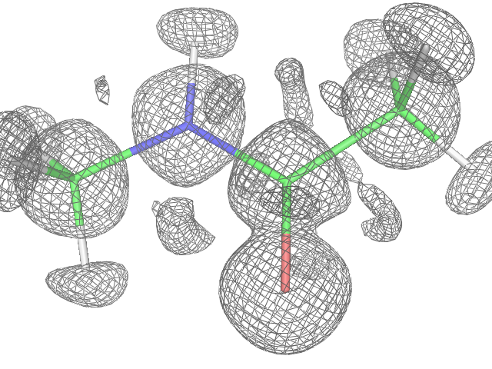
a) 0.9 Å
b) 0.7 Å
c) 0.6 Å
d) 0.5 Å
e) 0.4 Å
f) 0.3 Å

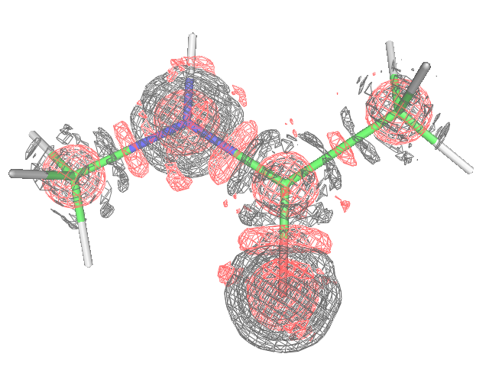
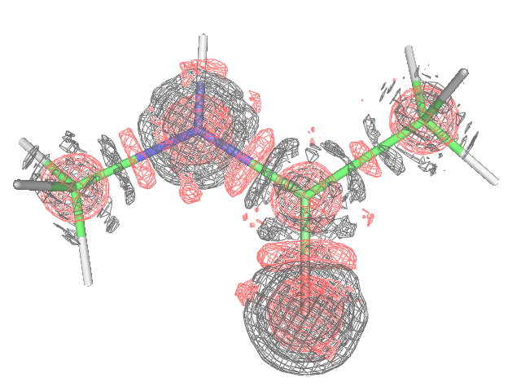
a) 0.5 Å and 0.4 Å

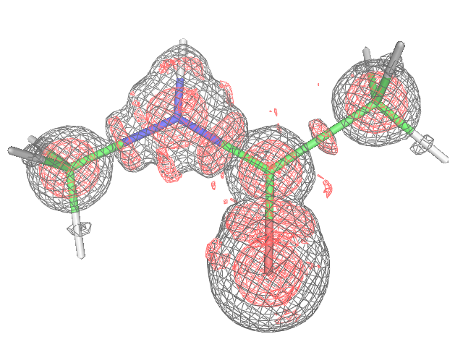
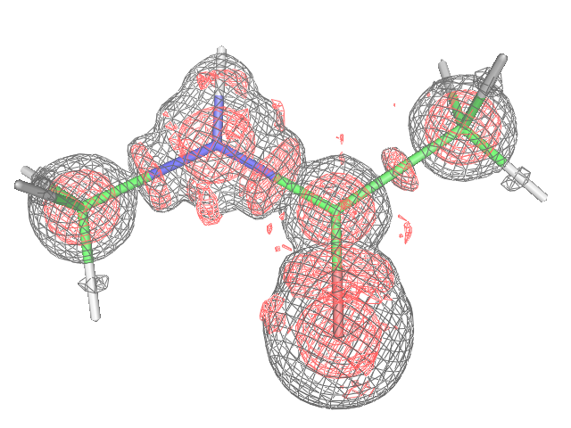
b) 0.5 Å, B=0 and 2Å²

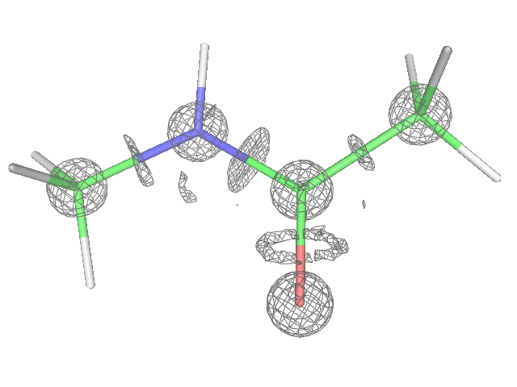
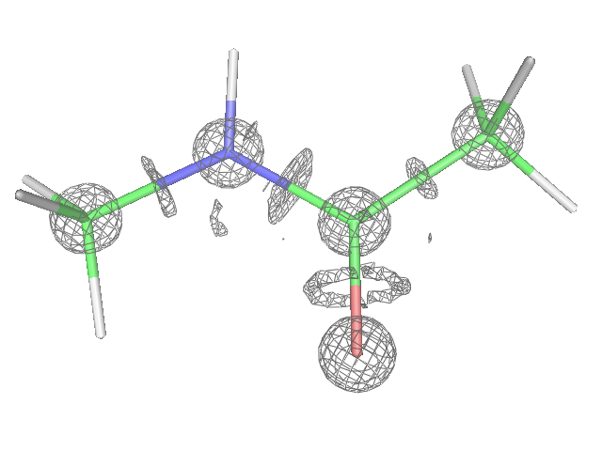
c) 0.5 Å, difference map

Fig. 4. a) Superposition of maps calculated with the Fourier coefficients {F^{spher}(s)exp[iϕ^{spher}(s)]} for B = 0 at the resolution of 0.5 Å (red) and at the resolution of 0.4 Å (black);
b) Superposition of maps calculated at the resolution of 0.5 Å with the Fourier coefficients {F^{spher}(s)exp[iϕ^{spher}(s)]} for B = 0 (red; cut-off 2.8 e/Å³) and B = 2 (black; cut-off 1.3 e/Å³);
c) difference map at the resolution of 0.5 Å between the densities for the models with B = 1 and B=2 (see Section 5 for a detail description); cut-off 0.5 e/Å³ .

Fig. 3. Map calculated with the Fourier coefficients {F^{spher}(s)exp[iϕ^{spher}(s)]} for B = 0. a) resolution 0.9 Å ; cut-off 0.9 e/Å³ ; b) resolution 0.7 Å ; cut-off 1.4 e/Å³ ; c) resolution 0.6 Å ; cut-off 2.0 e/Å³ ; d) resolution 0.5 Å ; cut-off 2.8 e/Å³ ; e) resolution 0.4 Å ; cut-off 3.2 e/Å³ ; f) resolution 0.3 Å ; cut-off 2.9 e/Å³ ;

