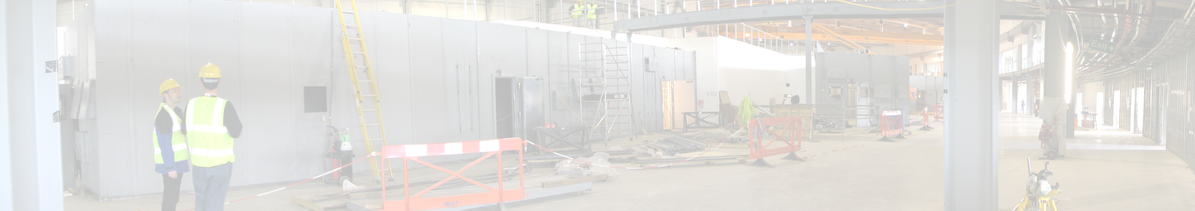
Diamond: Status Report on MX Beamlines and Computing
http://www.diamond.ac.uk

The Synchrotron
Table 1. Diamond at a Glance
Electron Beam Energy | 3 GeV
Circumference - Storage Ring | 561.6 m
Number of cells | 24 double-bend achromatic
Insertion devices straights | 4 x 8 m
 | 18 x 5 m
Beam current | 300 mA (500 mA)
Beam emittance | 2.74 nm rad (horizontal)
 | 0.0274 nm rad (vertical)
Beam life time | >10 h (20h)
Diamond is a new synchrotron radiation source being built at the site of the Rutherford Appleton Laboratory in Oxfordshire. The facility will comprise a 3 GeV electron storage ring, injected from a 100 MeV linac through a full energy booster synchrotron, and an initial complement of seven beamlines. The properties of each beamline were developed following extensive consultation with user communities to deliver a facility optimised for a range of applications, including macromolecular crystallography (MX).
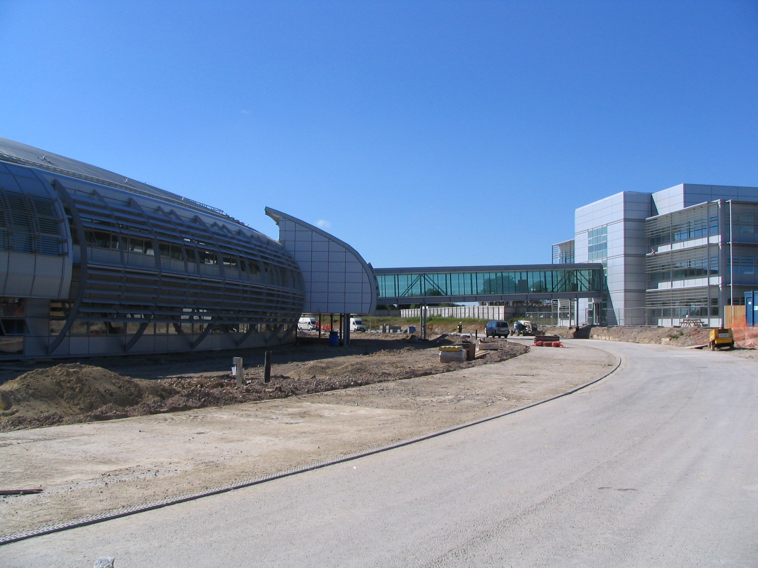
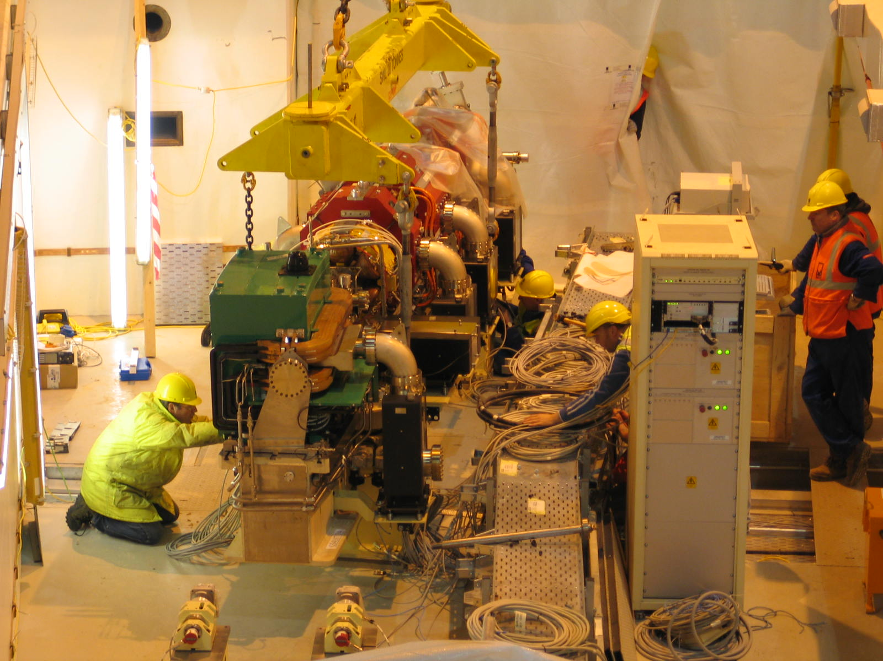Figure 1: June 2005
Left: Installation of a storage ring girder.
Right: exterior of the diamond experimental area building, connecting bridge and office block housing Diamond staff since February 2005.
The MX Beamlines
The first set of seven beamlines will go into operation in January 2007 and will include three macromolecular crystallography beamlines designated I02, I03 and I04. A microfocus beamline and a fixed wavelength side-station are planned for a later stage. The first three beamlines will receive radiation from in-vacuum undulators. The optical hutches for each beamline will contain a fixed exit Si111 double crystal monochromator, with the first crystal indirectly cryogenically cooled and the second thermally linked to the first to ensure matching of the crystal planes. Two bimorph mirrors will allow independent horizontal and vertical focusing. In addition, prior to each principal component are a set of slits and at least one diagnostic. A schematic of the optical elements is shown in Figure 2. The hutches for each of the beamlines are now complete. The assembly work has started on the optical components, and their installation is due to be completed by the end of 2005.
Table 2. Technical details for beamlines I02, I03 & I04
Rapidly tuneable | 0.5 – 2.5 Å
High flux | 10¹² ph/s in 100 μm x 100 μm at 1 Å
Small beam size | 10 – 200 μm (FWHM)
Low beam divergence | < 100 μm (V) x < 50 μm (H) at 1 Å
Detector | ADSC Quantum 315
Robotic sample changer | Rigaku/MSC ACTOR
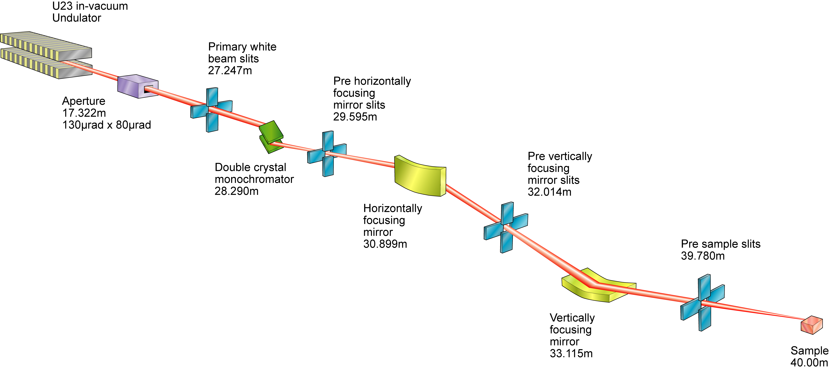
Figure 2. Schematic representation of MX hardware down the beamline.
The beamlines will all be tunable over a wide wavelength range to enable Multiwavelength Anomalous Diffraction (MAD) experiments to be carried out. Each beamline will be optimised for operation around 1 Å as it is anticipated that a significant amount of work will be MAD experiments at the Se K-edge at 0.979 Å. All three beamlines have very similar specifications, but I03 is unique since it will also include Category 3 biological containment in the experimental hutch.
The detailed design work for the experimental hutches is close to completion. Each hutch will contain a single-axis rotation stage, CCD detector, robotic sample changer, fluorescence detector and cryocooler. The beamlines will be capable of fully automated operation by combining robotic sample mounting with software-controlled loop (or crystal) centring and automated data collection software. However, completely manual operation of the beamline will still be possible for the traditionalists!
The robotic sample changers will be supplied by Rigaku/MSC and will operate with both flash-cooled crystals in loops and room-temperature crystals mounted in capillaries. An on-axis viewing system will give the user an “X-ray’s view” of the crystal, making it easier to select a specific region of the crystal to be exposed to the X-rays. Three ADSC Quantum 315 detectors, with large active areas of 315mm x 315 mm and very fast readout times of 0.25 - 0.9s, have been ordered for the beamlines.
Facilities will also be available for sample storage and manipulation with the provision of basic equipment such as microscopes, pipettes and crystal freezing facilities.
Table 3. Timescales
First electrons into storage ring | January 2006
First beam on the beamlines | April 2006
First beamline commissioning | April/May 2006
Commissioning with users | October/November 2006 onwards
User operations | January 2007
Further MX Beamlines
In August 2004, work commenced on the design of the microfocus macromolecular crystallography beamline I24. This beamline will produce a focused X-ray beam of less than 5 μm enabling the measurement of diffraction data from tiny, weakly diffracting crystals. The microfocus beamline is currently scheduled for completion in 2008.
A fixed wavelength (around 1 Å) side-station for "high-throughput" applications (I04.1) is due online in January 2009.
There are also plans for a beamline which will be optimized for data collections at long wavelengths. This beamline would be particularly suited for Sulphur SAD experiments. The timescales for this project are still to be determined.
Computing at Diamond.
The scientific IT needs of Diamond are met by the data acquisition and scientific computing group. The group is part of the Science Division within the structure of the Diamond Light Source. Its members engage to provide computing support for our scientific staff in the collection and analysis of data from all beamlines, and as such, perform a key role in the research emerging from Diamond.
Prior to the user arriving at the synchrotron it is hoped that data management and information capture will have occurred throughout the process undertaken to gain a crystal and stored in a Laboratory Information Management Systems (LIMS). One such LIMS being developed is the PIMS (Protein Information Management System, www.pims-lims.org). As Diamond is a partner in the PIMS project, work is already underway to ensure that relevant information about a sample, which will assist data collection, will be easily transferred and available on the beamlines.
Table 4. Diamond computing at a glance.
Hardware Control | EPICS
Data Acquisition software | GDA
MX Experiment environment | DNA
Standard Operating System | RedHat Enterprise 4
Beamline data storage | 20 Tb RAID 50*
I02, I03 & I04 medium term data storage and extra computing | 160 Tb and cluster computing*
Long term data storage | Atlas Data Store – perpetual*
MX image data format | imgCIF/CBF
Long term data format | NeXuS*
*Currently being proposed.
For the beamline, development of Diamond’s data acquisition environment is benefiting greatly from a close collaboration with the current data acquisition group at the SRS in Daresbury. The Generic Data Acquisition (GDA, http://www.srs.ac.uk/srs/gda/gdaoverview.htm) will form an underlying, common architecture to all beamlines in Diamond and the JAVA based environment will have the ability to offer a customisable GUI or Jython scripting and enable remote viewing or monitoring and even the possibility of control if required.
An alternative interface to run and control the experiments on MX beamlines in Diamond will be provided by the automateD collectioN of datA (DNA) project (www.dna.ac.uk), a collaboration between a number of European facilities and academic sites including Diamond. The DNA software will facilitate the automated screening, ranking and collection of data from macromolecule crystals.
The detectors that will be on the first three MX beamlines will have the theoretical ability to produce in excess of 5 Tb of images every day, per beamline. But because MX data collection is not continuous it is envisaged that a data collection session will only produce in the region of 1 Tb of data though this still poses some interesting data management problems. The aim on the MX beamlines is to move the imgCIF/CBF images from the 2Tb RAID array attached to the detectors, immediately to a 20 Tb RAID array local to each beamline. Here the images will be available for experimental steering software such as DNA with its associated information management system ISPyB (www.e-htpx.ac.uk).
In addition the images will be collated at this point with metadata of the sample and other data from the beamline (e.g. a png of the crystal in the loop, or beamline settings) into an evolving file format known as NeXuS (http://www.nexus.anl.gov/). It is intended that the NeXuS file format will again be common to all beamlines and will be the basis for extracting other formats for legacy code.
The preferred route of external access to data collected on diamond will be through a tool known as a Storage Resource Broker (SRB). The SRB has the distinct advantage of making a single, unique and persistent point of reference to the data, whilst the actual location of the data itself may move. For an MX beamline the data are likely to be removed from the beamline’s 20 Tb RAID array within a week and only be available on a larger data store shared between all three MX beamlines. This larger data store will also be attached to a computing cluster which will be available to allow fast structure solution before leaving the synchrotron or even the beamline. The current aim is that the eventual home for the data collected at Diamond will be the ATLAS Petabyte data store (http://www.e-science.clrc.ac.uk/web/services/datastore).
However, by using SRB technology the location of the data will appear to be the same. The SRB currently has a number of interfaces including a programmable API and a web interface similar to a file browser. Work is also underway on the SRB to make the data available through a URI e.g. srb://data.diamond.ac.uk/MX/my/data.img.
Further Information
For more information on Diamond please visit the Diamond web site. http://www.diamond.ac.uk.

Alun Ashton¹*, Katherine McAuley²*, Sara Fletcher³*, Jose Brandao-Neto², Liz Duke², Gwyndaf Evans², Ralf Flaig², Bill Pulford¹, Thomas Sorensen² and Richard Woolliscroft¹.
¹ Data acquisition and scientific computing.
² Macromolecular crystallography beamlines.
³ Science Division.
* The main authors of this article. Material also kindly provided by the Diamond communications group.

Diamond Light Source, Diamond House, Chilton, OX11 0DE.

