Using Installshield Universal

Introduction

This document outlines how to create an installer for a Linux machine (could also be for a mac). This is based on Installshield 11. If the version you are using is different than there might be things that will not be relevant or missing. Many things are similar to the normal installshield, so it is recommended to read “Using Installshield” first. If you have Installshield installed on your system, you should find the universal installer under “Installshield”->”Installshield Tools” in your programs groups.

Creating a new Installer

This is identical to the way you do it in Installshield, on the left choose “create a new project”. This time however there is only one type of project available “Universal Installer”

The Project Assistant

Again this looks very similar to the normal installshield. There are however a couple of differences.
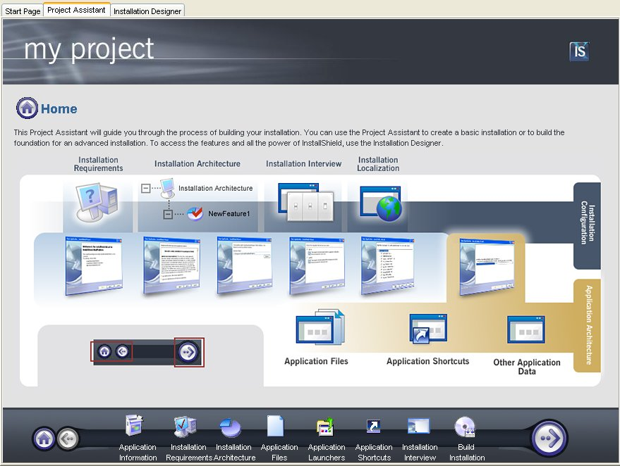
At the bottom you can see each of the steps that you will to go through. So let’s go through them one by one.

- Application Information: Identical type of information as for normal installshield

- Installation Requirements: In this one you actually have to specify which platform this installer is allowed to run on. In theory a single installer could be used for all platforms, but in our case we only use it for Linux.

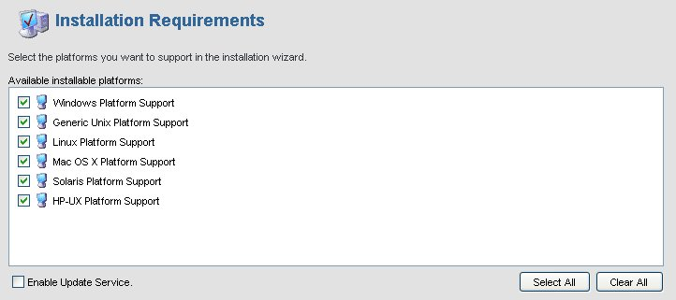

- Installation Architecture: Identical to normal installshield

- Application Files: This one is different and to some extent much more practical and simple than the one in the normal installshield. In here it is safe to add a directory even if it is dynamically linked as there no weird tag associated.
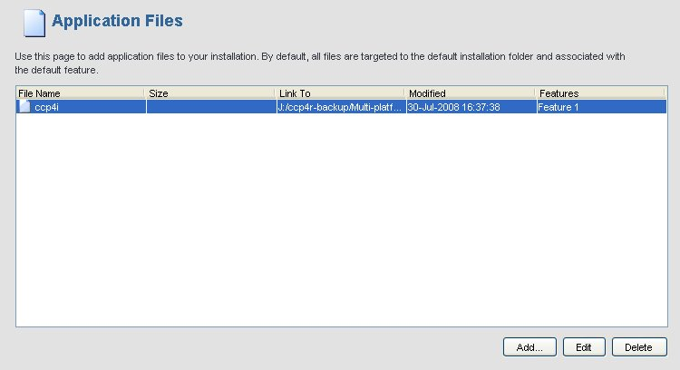
If you click the edit button you will have a window with 3 tabs: “General”, “Filter” and “Attribute”. In the general section you can modify the source of the file/directory and also have a checkbox at the bottom for adding subdirectories automatically or not. In the filter section you can choose what to include or exclude. For example I could filter out the file “phaser” if I was adding the binaries for the core ccp4 features. Finally the Attributes section lets you modify (or preserve) the attributes (reading, writing, executing) of the file. This is important to check if you are adding the files from a windows machine, it is probably not an issue if you do it from Linux (oh yes by the way this can be installed on a linux box rather than windows if you prefer).

- Application Launcher: This gives you the chance to wrap the installer into a binary file that will look native on the system you will run it on. Otherwise it would be a simple jar file. It is especially useful as you can bundle a java virtual machine with it so that the destination computers do not require to have it installed beforehand.

- Application Shortcuts: This is the same as installshield. However you have to give .xpm files rather than .ico files. It needs checking but as far as I know it does not work, or at least when I set it up and install, I never got shortcuts on my desktop.

Installation Interview: Identical to normal installshield, but I would recommend giving an html file for the license and you also have much more “skins” to choose from.
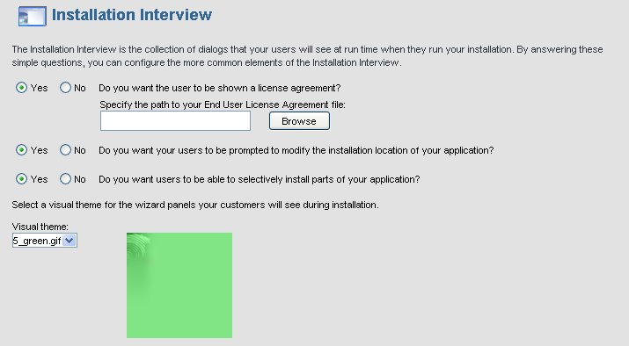

- Build Installation: again this is identical to the normal installshield, and similarly you have much more control from the installation designer view so it is recommended to modify paramaters from there.

The Installation Designer

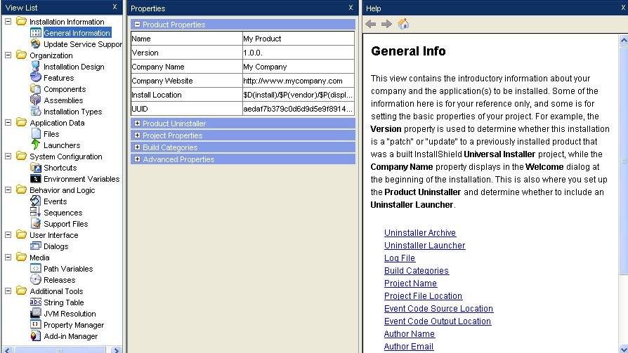
There are fewer options than in the normal installshield and most of the things looks familiar but there are more options concerning the platforms themselves. I will mainly explain those highlighted in green.

- Installation Design: It is very similar to the one in the normal installshield. There is however a little thing I like about it. You can specify the directory installation, but it is done in a clever way. For example in the screenshot below, the top level called CCP4-Packages has its installation directory set by properties coming from dialog widgets. However you also can see that the directory set for CCP4 is only ccp4-6.0.2. And lower in the tree the component program has its directory only set to bin/. You get the idea, all of the directory information is using a path that is relative to the path of the parent node. 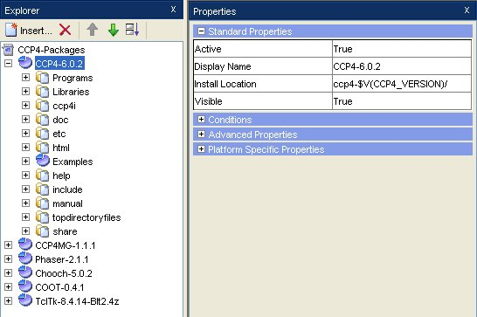
This is practical because, you can add a full directory (for example ccp4i) and its subdirectories and set the install location correctly directly. Especially in our case, as for example we can not add the top ccp4 directory in directly as some bits need filtering out.

- Environment Variables: This is identical to the normal one, there is more however, since you can choose which platform to set this variable on. However it is not used by the linux installers as it was reported that users prefer having control over adding the environment or not. This can not be put on or off through the installer itself which is why I am using a script. (see Sequences below)

- Sequences: As you may have noticed, there is no “custom actions”. There is still a way of running executables though. When looking at the sequence zone you have three sections. Pre-Install (contains all the interview dialogs), install (copying stuff, setting environment etc…) and Post-install. If you do a right-click on Post-Install you will see that you can choose an option called “Wizard Action”. You will then be presented with a whole list of possible actions that can be launched. The one that correspond the most to the “launch executable” from the normal installshield is “Execute Process”. Once you choose it, as shown on the picture below, you will have to give it the command name (actually browsing to the file that is to be executed), giving the commands arguments. Finally you also can specify whether to wait for the completion of the execution or not before continuing with the installation process, whether or not to bundle the executable and also giving a small description so that you can remember what the action is about.
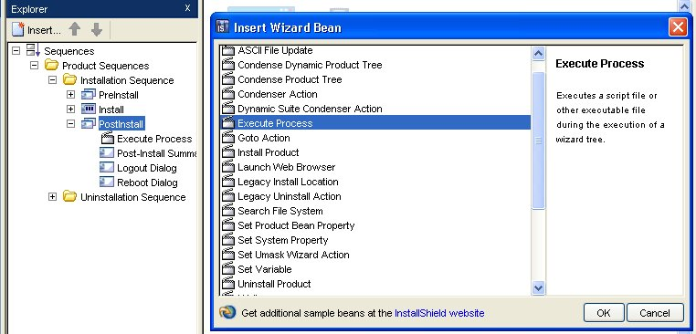
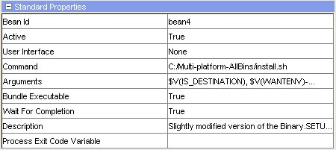
As you can see in the screenshots above, the way to reference an installshield property from the dialogs is $V(propertyname). The sequence area (see above) is also the place where you insert your dialogs, you usually insert them by doing a right-click on the dialog that should come after. But if you make a mistake, the right click menu lets you move a dialog up and down in the sequence as well. When you create a dialog, always remember that you need to insert it here.
Dialogs: The idea here is very similar to what you have with the normal installshield.
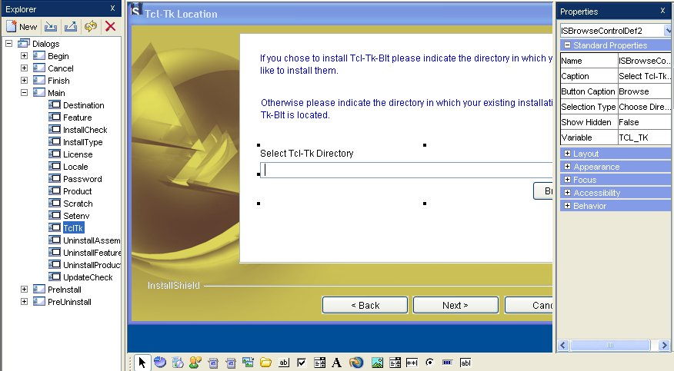
The only differences are that the toolbar for adding widgets is at the bottom rather than at the top, the widget are not identical, here what was called “property” before is called “variable” and instead of using [var] to get the value of a variable you need to do $V(var) instead. Also you do not have the separation between behaviour and design. Anything that is to do with response to event as to be coded in javascript using the tabs at the bottom, under the toolbar. Personnaly I have never taken the risk of doing that, because I did not need it so far.

- Releases: This one is quite different from the normal installshield. The release area has 3 categories. Firstly the platform section lets you choose which platform to create an installer for. The second one lets you specify which language are supported and the last one lets you specify parameters for the launchers (a launcher is a jar wrapped up in a .bin file so that it can be executed like a program) such as the name or error message report. There is not much to do here, only need to pickup the right platform(s).
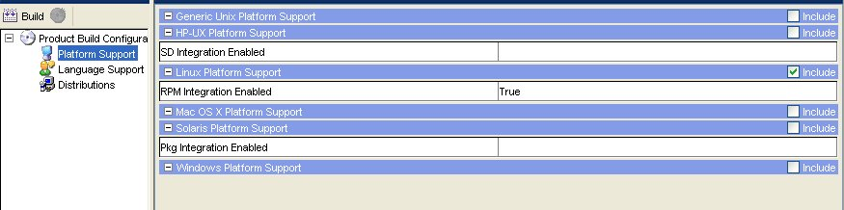

- JVM resolution: This bit does not exist in the normal installshield. This actually lets you define the JVM (Java Virtual Machine) searching type for each launcher. This means which product will be searched for on the system and in which order. This is because the installer needs java to run. This might sound like a drawback but you actually can bundle one JVM within the installer so that if none is found on the system then it will use its own bundled java to run the installer. This ensures that there is no external requirements for the installer.


